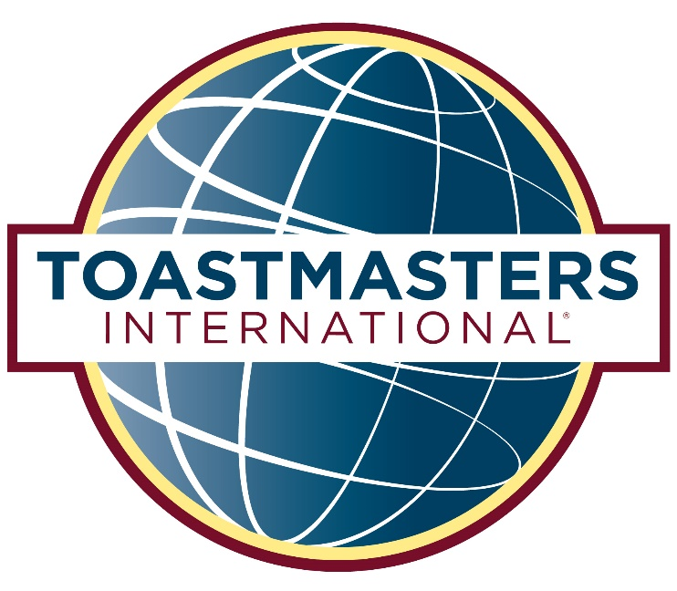

<http://district52.org>

### Saturday, September 33, 2017

Fire Station #1000

12545 Vista Rd.

San Fernando, CA 91376

AREA X50

EVALUATION and

INTERNATIONAL

SPEECH CONTEST

THANK YOU  
FOR YOUR SUPPORT

Many thanks to all who contributed their time, talents, and efforts to make this contest possible. We could not do it without you!

Today’s 1st place winners advance to the next level of contests. Please support them by attending:

# Division X Contest

## Saturday, October 33rd

**XYZ Company**

12345 Industry Circe

Los Angeles, CA 91234

# District 52 Spring Conference

## May 11-13, 2018

**Odyssey Banquet Center**

15600 Odyssey Drive, Granada Hills, CA 91344

Register by August 34th and pay only $150

First-Timers receive a $15 discount

FUNCTIONARIES

Contest Chair……………………………………….. Jane Deaux

Toastmaster………………………………………Sir Speaks a Lot

Chief Judge ……………………………………. Presiding Judge

Ballot Counters John Smith, Nomad Jones,

Timers……………………………………….Hour Glass, Doris Day

Sergeants-at-Arms…………………………Wait A. Second, G.I.Joe

Refreshments Chair………………………………Mary Drinkwater

(In Alphabetical Order)

# Evaluation Contest

### Area X50

First Name Last Name

First Name Last Name

First Name Last Name

First Name Last Name

# International Contest

### Area X50

First Name Last Name

First Name Last Name

First Name Last Name

First Name Last Name

## Opening Remarks

## Welcome and Introductions

John Doe, Contest Chair

## Contest Opening

Jane Doe, Toastmaster

## Evaluation Speech Contest X50

## Interviews

## Presentation of Awards

## ~Break-10Minutes~

## 

## International Speech Contest X50

## Interviews

## Presentation of Awards

## 

## Recognition of Volunteer Leadership Team

## Announcements

CONTESTANTS

PROGRAM SCHEDULE