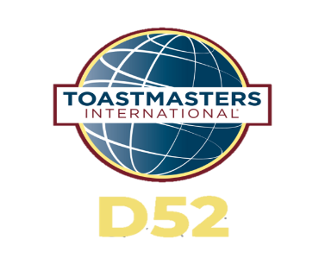
District 52 Call for Nominations
2024-2025 District Leaders
The District Leadership Committee (DLC) is accepting applications between December 1, 2023, to February 29, 2024 for the elected District Leadership positions for the Toastmasters 2024-2025 program year.

Frequently Asked Questions
What is the District Leadership Committee?
The District Leadership Committee (DLC) qualifies and nominates candidates through assessments and interviews. The district leadership nominated candidates will be elected by the District Executive Committee at the Annual Business Meeting in May of 2024 for the 2024-2025 term.
Who are the members of the committee?
The committee consists of 6 members and is chaired by Immediate Past District Director, Rose Abbott, DTM. The DLC Chair selects a representative for each Division to serve on the DLC Committee with approval from the District Director.
What District Leadership positions are open for nomination?
The open District Leadership positions that are elected are:
- District Director
- Program Quality Director
- Club Growth Director (2 candidates required)
- Division A Director
- Division B Director
- Division C Director
- Division D Director
- Division E Director
- Division F Director

What are the qualifications for each position?
Read the qualifications for the position you intend to run for here: District Executive Committee Roles
What are the Competencies for each District Leadership Role?
District Leader Competencies PDF
Do I have to fill out any forms?
Yes, download the District Leader Nominating Form and submit to DLC Chair via email to nominate yourself or another qualified Toastmaster.
When are nominations being accepted?
Nominations are being accepted December 1, 2023, through February 29, 2024, 11:59 p.m. Pacific.
Who do I submit the nomination form to?
Please submit to the Committee Chair, Rose Abbott, DTM, IPDD
When are the District Elections?
The elections will be held during the Spring Annual Business Meeting on May 17, 2024
Where may I find the District Campaign and Election Protocol?
Protocol 9.0 may be found here: Toastmasters International -Governing Documents
When are the interviews going to be conducted?
Candidate interviews will be scheduled between March 1 to March 30, 2024.
Why do I need to be interviewed?
All candidates running for elected positions must be qualified and possess the core competencies needed for the district leadership role.
I have been interviewed for one position; do I have to interview again for another position if I want to run for that position instead?
Yes. Interviews are conducted to qualify you for each position you intend to run for.
I missed the deadline. Can I still run?
Yes, candidates can still run from as a floor candidate.
Do I still need to be interviewed if I’m running as a floor candidate?
Yes. The committee must evaluate the specific position you are running for. A nomination from the floor also must be made.
Floor candidates are candidates who wish to run for district leader but have missed the deadline. Floor candidates must submit an application and be qualified to run.
Is there a deadline to run as a floor candidate?
Floor candidates must notify the district director know in writing of their intention to run before May 10, 2024, at 11:59 PM.
I have more questions, who do I contact?
Please reach out with your question in an email to Rose Abbott, DTM, IPDD

